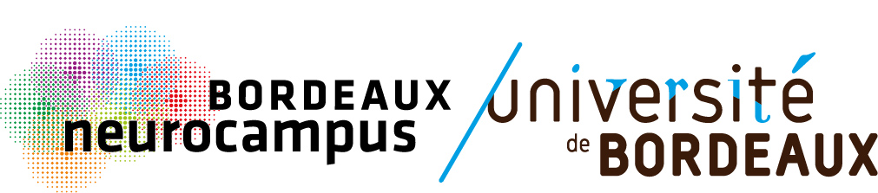

Call for proposal

Marian Diamond Prize 2025

OBJECTIVES

Bordeaux Neurocampus launches its annual call to recognize outstanding achievements in Neuroscience of an early career female researcher in our community.
Marian Diamond (1926–2017) was a groundbreaking American neuroscientist who first demonstrated anatomical neuroplasticity and advanced neuron-glia research with her study of Einstein's brain. Initiated by the Neurocampus Parity and Inclusion Committee (NeuroPIC), the Marian Diamond Prize aims to raise the profile of female neuroscientists at a crucial stage in their careers, the postdoctoral period, when they face many barriers to reach academic positions.
The members of the NeuroPIC will evaluate the proposals and announce the laureate during the PhD Seminar on February 7th 2025, which will be extended on the occasion of the International Day of Women and Girls in Science (February 11th). The laureate will be expected to briefly present themselves immediately after the award announcement (e.g., motivation for applying for the award, current career objectives or research interests, etc). The award includes a prize of €1000, and an invitation to give a plenary lecture on June 4th 2025 at the Bordeaux Neurocampus Day.

ELIGIBILITY CRITERIA

- Be a non-tenured postdoctoral female researcher with a minimum of 3 years’ postdoctoral experience (based on adjusted academic age) on 07/02/2025.
- Be under contract in January 2025 as a member of a Bordeaux Neurocampus institute.
- Be present on campus on February 7th and June 4th 2025. Previous laureates are not eligible.

EVALUATION CRITERIA FOR THE AWARD

- Positioning/impact of the research work in the scientific field in relation to opportunities. That is, the researcher’s activities, results and achievements are evaluated in the context of career and life experiences, including significant career interruptions.
- Involvement in the scientific community, including support for diversity, equity, and inclusion, and science outreach (e.g., DuoDay, Déclics, La semaine du cerveau, student/patient associations, etc).

SUBMISSION

Send your application by e-mail to
aap.neurocampus@u-bordeaux.fr
Deadline: Wednesday, January 15th 2025, 5.00 P.M. Please note that no feedback will be provided.

Call for proposal

Marian Diamond Prize 2025

NAME:

INSTITUTE / TEAM LEADER:

ADJUSTED ACADEMIC AGE:
This should be calculated as the period from the PhD degree or equivalent to the current year, minus any periods of leave (in months) due to maternity leave, long-term illness, clinical training and/or national service, or time spent outside university research institutions, if applicable.

NARRATIVE CURRICULUM VITAE (1 page max)

The CV should clearly state the applicant's background and research objectives, as well as their main achievements. A narrative CV should use a storytelling approach to present your career history, skills, and achievements in a flowing descriptive format, emphasizing the context, motivations, and impact behind your experiences, rather than listing roles and responsibilities in bullet points.

IMPLICATION IN THE SCIENTIFIC COMMUNITY (0,5 page max)
Applicants should describe their contribution to the community, including evaluation (publications and grants), teaching, actions to promote gender equality or diversity, or science outreach...

BIBLIOGRAPHY (1 page max)
Please clearly separate original and review/opinion articles. Pre-printed articles may also be listed in a separate section.

